RIVERS OF WEST AFRICA CRUISE 2012-13
8 day cruise on the Rivers of Gambia
On the 25 Cabin M/Y HARMONY V

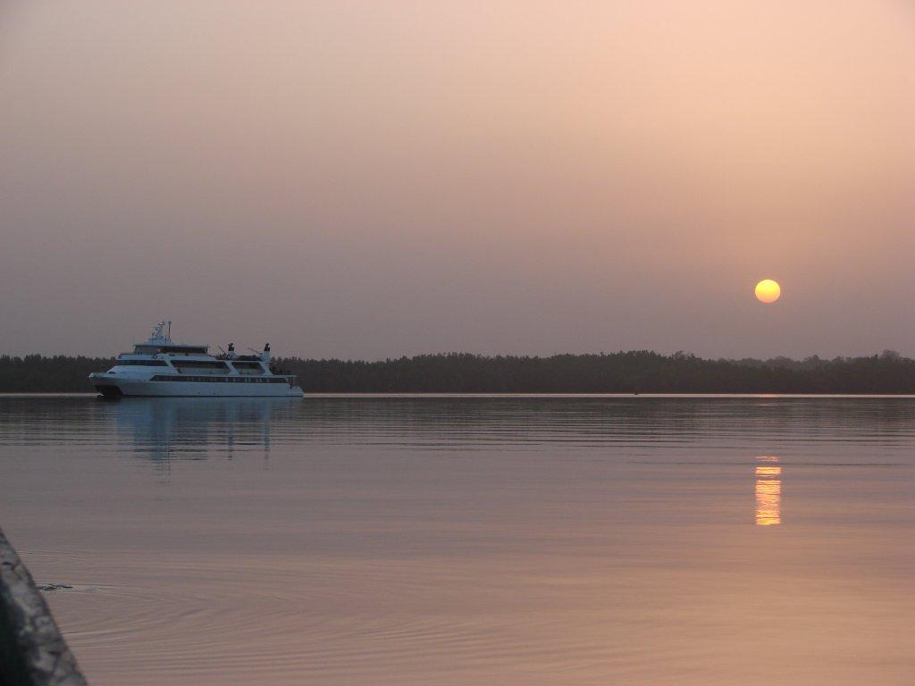

The Amphitrion Yachting Experience
Enjoy a harmonious balance between conventional cruising and private yachting, along with an exciting voyage of discovery, unravelling the wonders of West Africa. Each day you will discover a new port of call, a hidden cove with crystal blue waters to cool you, a glimpse of ancient history to amaze you and rich cultural diversity to intrigue you.

Safety on the Harmony V
The latest addition to the Amphitrion Yachting fleet, the HARMONY V, is a 183 ½ foot-wide Mega yacht was launched in July 2009. The HARMONY V complies with EUROSOLAS safety regulations, ISPS (International Ships Port Safety Code) ISM, (International Safety Management), while its powerful engines, generators and state of the art twin stabilizers will allow for safe and comfortable cruising.

Life on Board
The HARMONY V is a modern Mega yacht with a sleek high-tech look very similar to the private yachts to be found in the famous ports of the world.
Life on board will centre around the Bar Lounge and Dining Room at the Main Deck and at the Sun Deck Bar where meals are served “al fresco” depending on the weather and the ship location. The classy dining room and the adjoining cosy bar lounge are surrounded by large windows providing beautiful views of the ports of call It accommodates all guests in one single seating and provides a high standard of cuisine, always with some local flavour. The Sun Deck is the ideal place to bask under the sun, read a good book or just gaze at the scenery. The swimming platform on Harmony V stern will allow for easy access to the ship and for a wide range of sea related activities. Service on board is provided by your Captain, the Cruise Coordinator and your experienced Marine and Hotel crew members. Service will be attentive or unobtrusive according to your requirements and priority is always given to the safety and comfort of passengers. Organised excursions are available for most ports of call and can be pre-booked or reserved 24 hours in advance.

The Cabins on Harmony V
The 25 cabins of the HARMONY V are located on the Main deck (9 cabins) and on the Upper Deck (16 cabins). All cabins are premium and contemporary, decorated with soft colour furnishings. Cabins are comfortable and average size is 135 sq feet. All 16 cabins on the Upper Deck offer flexible bedding configuration, which can be set to offer either two twin beds or a double bed. The 9 cabins at the Main Deck consist of 6 double bedded cabins and of 3 twin bedded cabins (no flexible bedding arrangement).
All cabins offer large windows and en suite bathrooms with shower and elegant Corian finishing on walls and floors. The cabins are equipped with flat screen TV sets, DVD players, mini fridges, hairdryers, individually controlled A/C and safe deposit boxes.

The Rivers of West Africa - 2012 /13
7 nights cruise Dakar – Dakar (Friday to Friday)

Day 1: Dakar/Senegal
Late afternoon embarkation. After dinner, we set sail southward towards the Saloun River Delta. Overnight at sea, south along the coast.

Day 2: Djiffere – Banjul/the Gambia
This morning we reach the Sine – Saloun Delta in Senegal, an UNESCO Biosphere Reserve and also an Important Birding Area, as designated by Birdlife International and natural habitat for many bird species but also such aquatic animals as marine turtles, dolphins, West African manatees and crocodiles. Our optional excursion starts at the primitive fishing village of Djiffere from where we reach the village of Joal Fadiouth, set on an island of clam shells that also are used in local buildings and crafts. In the afternoon, we leave Senegal and the Saloun Delta and sail south to Gambia to reach Banjul, the capital of Gambia and gateway to the 700-mile Gambia River.
Fishermen Night - Overnight in Banjul.

Day 3: Banjul - Abuko Nature Reserves/the Gambia
The morning in Banjul will give you the opportunity to take the 1/2 day excursions offered to Bakau with its crocodile "katchikaly", its Botanic Garden and a short Banjul Tour.
After lunch, we leave Banjul and sail upstream. We stop at St. James Island in the middle of the Gambia River. The first settlers on the island arrived in 1651 and under the British rule it became an important slave trading post in The Gambia. In 1976 James Island became famous due to the author Alex Haley and its bestseller book "Roots" and the story of a slave, called Kunta Kinteh. The island was recently renamed Kunta Kinteh Island and is now a UNESCO World Cultural Heritage Site. After disembarking by local tenders your local guide will tell you more about the history of James Island and afterwards you will have some time to explore this island by yourself.
Late on the afternoon, we leave "Kunta Kinteh" and sail upstream to reach Tendaba.
Greek Night in Africa - Overnight at dock in Tendaba.

Day 4: Tendaba/the Gambia
From the ship we take motor pirogues in order to reach Tendaba, located on the South Bank in the Lower River Division, our starting point of our morning optional excursion. It is a small fishing village of mainly Muslim faith with approximately 600 inhabitants whose main occupation is fishing. From there we will walk through to Batelling, a small village at the entrance to Kiang West National Park. The area boasts of over 250 species of birds; many of which are difficult to observe anywhere else. Other residents include Guinea baboons, bushbuck, warthogs, Senegal bushbaby and marsh mongoose. After a refreshing stop in Batelling, we will board an open safari truck which brings us back to Tendaba. On the way we pass again local villages where you get an impression of local life in The Gambia. In the afternoon, we are picked-up from the ship by motor pirogues for another optional excursion to the Bao Bolong Wetland Reserve. This reserve, lying across from Kiang West National Park features six major bolongs (creeks) that provide great birding and boating opportunities. Numerous rare and migratory birds also reside here including the Pel’s fishing owl, African fin foot and brown-necked parrot.
Overnight docked in Tendaba.

Day 5: Gambia River – Kuntaur - River Gambia National Park/the Gambia
Early morning we leave Tendaba and sail upstream on the Gambia River all morning to reach Kuntaur. Early afternoon arrival to the bustling Gambian port town of Kuntaur, the last inland stop along the river that is navigable for ocean-going ships.
Later in the afternoon we board a large motor pirogue for a 3 hours optional excursion cruise on The Gambia River. First we head to the southernmost tip of Baboon Island, one of the five islands of The Gambia National Park. There a local national park ranger is joining us onboard in order to

give more information about the park and its fauna & flora. Then we turn, the motor pirogue slows down and sails slowly back to Kuntaur following closely the shores of Baboon Island. This island is home of the Chimpanzee Rehabilitation Project. If we are lucky from our motor pirogue we can closely observe the chimps with minimal intrusion. There is also the possibility of seeing hippos, crocodiles, Red Colobus, Green Vervet monkeys and also The Gambia’s famous birdlife.
We return to Kuntaur where we are met by the “Kankurang” and a local dance group on the pier. Believed to have spiritual powers the “Kankurang” dispenses justice and wards off evil spirits.
Overnight docked in Kuntaur.

Day 6: Kuntaur – Jangjanbureh- Kaur/the Gambia
This morning, our optional excursion by bus takes us to the ferry station of Janjanbureh. There we board the local ferry for a short cruise over The Gambia River to Janjanbureh. We continue our excursion with a visit of one of the oldest towns of The Gambia, formerly called Georgetown. During the walk you get an impression of this laidback town and see the residence of the governor, the market and the Methodist church with its school. Afterwards we take the ferry back and re board the bus to reach Lamin Koto. Through the generosity of Amphitrion Yachting and of many of its clients, a new school building is being built. Later in the morning we stop at the mysterious stone circles in Wassu, a megalithic site believed to be a burial ground thousands of years ago. You will visit the little museum of this archaeological site, a UNESCO World Cultural Heritage Site.
In the afternoon, after lunch, we sail downstream to Kaur a small fishing village on the banks of the Gambia. You will have the opportunity to walk around this small community and see how Gambians live today.
Captains Farewell Dinner / Overnight in Kaur.

Day 7: Kaur - Banjul/the Gambia

We leave Kaur early in the morning and sail further downstream towards Banjul. Dolphins and other animal life will be sighted. Arrival in Banjul around 4pm. After formalities, later in the evening, we will sail out of the Gambia estuary into the Atlantic Ocean northwards to Dakar.
Gambian Night with Kora instrument Concert - Overnight at sea to Dakar.

Day 8: Dakar/Senegal

Early morning arrival in Dakar. Disembarkation after breakfast.

Itineraries can be changed at the discretion of Amphitrion Yachting and of the Vessel's Captain in case of adverse weather conditions - winds of 6/7 beaufort or more depending on the vessel - on port authorities not allowing a vessel to leave port or in case of other extraordinary conditions.
Such itinerary changes do not entitle automatically passengers to any refunds but Amphitrion Yachting guarantees that passengers are disembarked at the advertised port of disembarkation on time for their flights.

Notes: All excursions are optional.

Rivers of West Africa Cruise - 2012/13
7 nights cruise Dakar to Dakar on the Saloun and Gambia Rivers

SAILINGS DATES & GROSS EURO RATES
Dakar to Dakar - Fridays | 21, 28 December 2012  4* , 11*, 18, 25 January 2013  1, 8, 15, 22 February 2013  1, 8, 15, 22, 29 March 2013
CABIN CATEGORIES | GROSS RATES
Cat C  Main Deck, Double bedded Cabins | € 1,390
Cat B  Main Deck, Twin or Double bedded Cabins | € 1,690
Cat A  Upper Deck, Twin or Double bedded Cabins | € 1,990
Cat P  Upper Deck, Twin or Double bedded Cabins | € 2,390
Reduction for 3rd person in Cat. A | 30%
Single Supplement | 30%
Port Charges | €210

10% discount applies for Red Star* marked sailings

A/ Cruise fares are per person and week and include:
- Accommodation in double or twin cabins with private SH/WC & air conditioning.
- Full-board: American buffet breakfast and two main meals daily.
- Regular (filter) coffee, tea and water free all day.
- Use of fishing equipment (subject to availability).
- English Speaking Cruise Escort.
- Port charges (as shown and to be added extra to the cruise fare).
- VAT.

Not included:
- Beverages (except those mentioned above).
- Shore excursions or other land arrangements.
- Crew tips.
- Passenger personal expenses.
- Passenger Visas whenever required.

2HONEYMOON PACKAGE – DESCRIPTION, CONDITIONS AND RESTRICTIONS

1/The Honeymooners Package features:

- 25 % reduction for the bride
- Cabins with Double or King bed
- Welcome Honeymooners treatment including a Complimentary bottle of Champagne and a Fruit Basket;
- A Candle Lit Dinner at our Special Honeymooners location on board our ships (for all our programs outside Greece ) or at a preferred restaurant in Santorini or Mikonos for our Greek cruise programs;
- 10% discount for any wedding anniversary on board our ships;
- Automatic access to our Variety Club membership;
- “ Our Memories” gift at disembarkation;
- A free 1/2 hour massage for 2, if on board our Harmony V, Variety Voyager and Seychelles program vessel.

NOTES

1. Please ask the details for our "Wedding and Cruise with friends and family" private charter for 40 to 72 guests.
2. This package is also available to clients wishing to renew their vows. The Vows renewal ceremony is performed by our Ship Captains.

2/ Honeymoon offers : General conditions and restrictions
a/ The Honeymoon offer is valid only provided that the couple is traveling within 6 months from their wedding date (copy of marriage certificate required);
b/ The Package cannot be combined with any existing or future SPECIAL OFFERS.

B/ Conditions and restrictions

PROOFREADING Tour Operators featuring our Cruises in their Catalogue or Internet site by itinerary, vessel’s description and images, will send VARIETY CRUISES a draft for error-checking of the contents prior publication as well as two brochure copies when printed. In order to secure corect information given to our clients and keep our high customer satisfaction levels. Amphitrion Yachting will not bare any responsibility for innacurate information or misrepresentation of our vessels or cruise itineraries without having accepted a draft prior to the brochure going to print or internet page published.

PAYMENT 25% deposit is required upon confirmation. Balance of payment is due no less than 60 days prior to day of embarkation.

CHILD REDUCTION Children between the ages of 7-10 sharing a cabin with two paying adults receive a 50% discount. Children between the ages of 10-16 sharing a cabin with two paying adults receive a 35% discount. Port taxes are not discounted.

CANCELLATIONS 25% of the cruise for any written cancellation received between 60 to 31 days prior to sailing; 50% up to 16 days prior to sailing; full cruise fare for written cancellations received less than the 16th day prior to sailing or for “no shows” even if cancellation is due to unforeseen circumstances beyond passenger’s control. Cancellations must be confirmed by AMPHITRION YACHTING in writing in all cases.

AMENDMENTS There may be a charge for amendments of cruise date or decreasing pax number received less than 60 days prior to sailing. Amendments must be confirmed by AMPHITRION YACHTING in writing.

NOT INCLUDED IN CRUISE FARE Such personal expenses as drinks (other than included in the rate), laundry and gratuities, (gratuities are optional but as a rule, satisfied clients are
expected to give to the captain, at the end of the cruise, approximately Euro 8.00-10.00 p/p p/day for distribution among crew members) medical expenses, port taxes, shore excursions (shore excursions are proposed and arranged on board by the tour leaders) expenditures incurred ashore, and anything not mentioned in cruise program.

